MINISTRY OF EDUCATION AND SCIENCE OF UKRAINE

NATIONAL TECHNICAL UNIVERSITY

“KHARKOV POLYTECHNICAL INSTITUTE”

LABORATORY WORK №6

Using pointers to functionsand header files

Created by student of 1.КН.201.8г

Chukwu Irele omike

Teacher

LUTENKO I.V

KHARKIV 2018

Laboratory Training 6

**1.1 Bisection Method**

Implement Bisection (Dichotomy) method using separate units and header file. Use pointers to functions.

**1.2 Individual Assignment**

Write a program that implements exhaustive search of some value according to an individual assignment. Necessary value can be found by testing intermediate values of a function. Use typedefs and pointers to functions.

The source code should be split into two translation units. The first translation unit will be represented by both header file and implementation file. The **typedef** definition, as well as declaration of function that searches necessary value, should be placed into header file. The definition of this function will take place in implementation file corresponding to header file. The testing function, as well as main() function, should be placed into another translation unit.



Task 1: the code

Source.cpp

#include"Header.h"

void main()

{

cout << root(g, 0, 6) << endl;

cout << root(sin, 1, 4) << endl;

}

Header.h

#pragma once

#include <iostream>

#include <cmath>

using std::cout;

using std::endl;

using std::fabs;

typedef double(*FuncType)(double);

double root(FuncType f, double a, double b);

double g(double x);

Source1.cpp

#include "Header.h"

double root(FuncType f, double a, double b)

{

double eps = 0.001;

double x;

do

{

x = (a + b) / 2;

if (f(a) * f(x) > 0)

{

a = x;

}

else

{

b = x;

}

} while (b - a > eps);

return x;

}

double g(double x)

{

return x * x - 2;

}

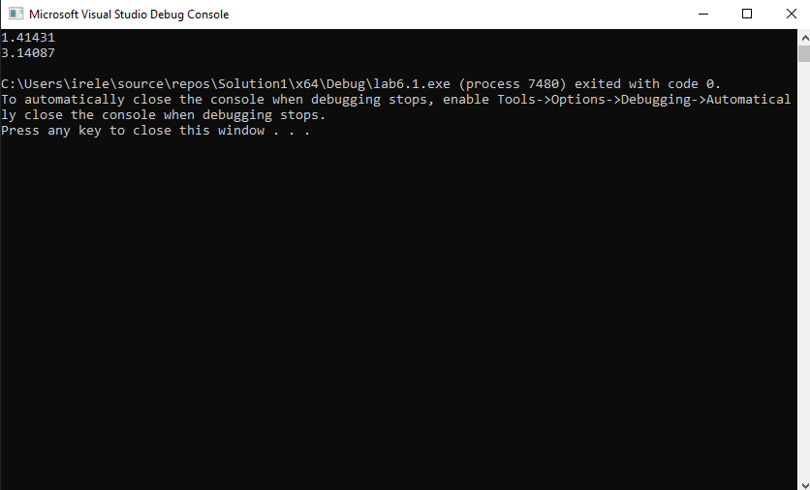

Task 2 :the code

Source.cpp

#include "pch.h"

#include "Header.h"

int main()

{

double h, a, b;

int n;

//setlocale(0, "UKRAINIAN");

cout << "Enter the value of the start of the interval: ";

cin >> a;

cout << endl << "Enter the value of the end of the interval: ";

cin >> b;

cout << endl << "Enter the interval of the interval: ";

cin >> h;

cout << endl << "Enter n: ";

cin >> n;

if (a > b)

cout << endl << "Beginning can not be more than end" << endl;

else

cout << endl << "quantity of roots = " << count(y, a, b, h, n) << endl;

system("pause");

return 0;

}

Header.h

#pragma once

#include <iostream>

using namespace std;

typedef double(*funcT)(double, int);

double y(double x, int n);

int count(funcT f, double a, double b, double h, int n);

Source1.cpp

#include "Header.h"

double y(double x, int n)

{

double rez = 1;

if (x > 0)

for (int i = 1; i <= n; i++)

for (int j = 0; j < n; j++)

rez *= x - i - j;

else

{

rez = 0;

for (int i = 0; i <= n; i++)

rez += (x - i)*(x - i);

}

return rez;

}

int count(funcT f, double a, double b, double h, int n)

{

int N = 0;

while (a <= b)

{

if (f(a, n) == 0)

N++;

a += h;

}

return N;

}

